**Wathare Infotech Solutions Assignment**

**Topic** : Create a web application that allows users to view live data updates on charts.

**Assignment**:

* User can see the population of each state in India.
* Whenever the value of any state updates so user can be able see the updation value.
* User can see the chart in different ways like pie chart,line chart,bar chart,etc.
* This Application is built by using MERN(MongoDb,Express,React,Node)..
* I have used population of State in Indian API.
* The Updation data can be directly stored into the database and that data will be fetched from the database to show to the users.

1.Bar Chart

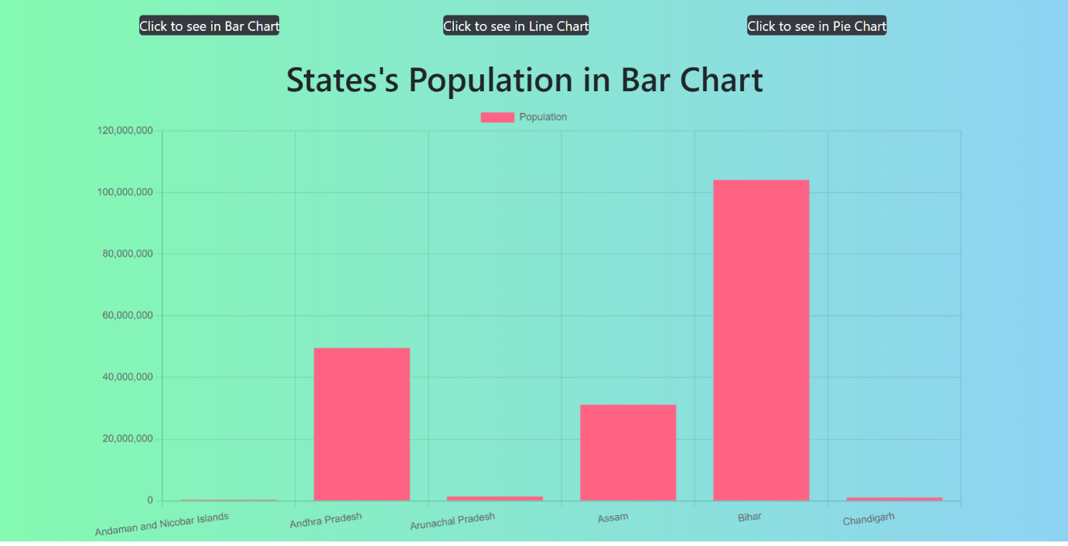

2.Line Chart

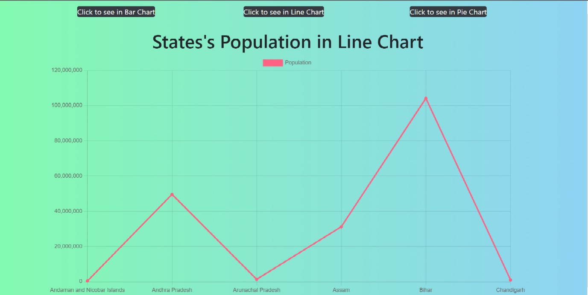

3.Pie Chart

